EMAIL TO DELTASIG ALUMNI AND YOUR NETWORK (BEFORE THE CAMPAIGN) – Send Nov 2-5
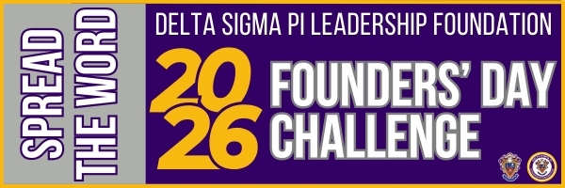
Subject Line: My Delta Sigma Pi chapter needs you on November 6-7!
Dear [FIRST NAME],
We are just a few days away from Deltasig’s Founders’ Day Challenge! To celebrate Delta Sigma Pi and our Founders, we are hosting two days of giving beginning Friday, November 6! This is the perfect opportunity to give back to my chapter, [INSERT CHAPTER NAME].
Your gift can help send collegiate brothers to national Fraternity events such as LEAD, Grand Chapter Congress, Presidents’ Academy and more!
Learn more about our campaign at dsp.org/fdc and stay tuned for the start of the giving campaign on November 6!
Fraternally,
[YOUR NAME]

EMAIL TO YOUR NETWORK (FRIENDS/FAMILY/NON-MEMBERS) – Send Nov 6-7

Subject Line: Support my chapter TODAY during Delta Sigma Pi’s Founders’ Day
Dear [FIRST NAME],
Today marks 119 years since the founding of my Fraternity, Delta Sigma Pi, and to celebrate we are hosting Deltasig’s Founders’ Day Challenge, which focuses on helping chapters, like mine, fundraise for their Chapter Leadership Fund.
Why should you support our Chapter Leadership Fund? Chapter Leadership Funds (CLFs) help us reduce costs for Delta Sigma Pi educational programs, including registration, travel, and lodging. CLFs can also be used to cover expenses for educational or professional events like speakers, workshops, and conferences. By donating to our CLF, we can send more members to Fraternity events! If you want to learn more about the impact of CLFs, click here.
The Founders’ Day Challenge Giving Campaign (November 6-7) is the perfect opportunity to give back to my chapter. To make a direct donation to my chapter’s CLF, click here: [INSERT YOUR CHAPTER’S CLF LINK]. To learn more about Founders’ Day challenge, go to dsp.org/fdc.
Thank you for supporting my future and my chapter, [INSERT CHAPTER NAME]!
Thank you,
[INSERT YOUR NAME]

EMAIL TO DELTASIG ALUMNI (GENERAL) - Send Nov 6-7

Subject Line: Support my chapter TODAY during Delta Sigma Pi’s Founders’ Day Challenge
Dear [FIRST NAME],
Happy Founders’ Day! To celebrate Founders’ Day, consider donating to my chapter’s Chapter Leadership Fund during the Founders’ Day Challenge.
Why should you support our Chapter Leadership Fund? Chapter Leadership Funds help us reduce costs for Delta Sigma Pi educational programs, including registration, travel, and lodging. CLFs can also be used to cover expenses for educational or professional events like speakers, workshops, and conferences. By donating to our CLF, we can send more members to Fraternity events! If you want to learn more about the impact of CLFs, click here.
The Founders’ Day Challenge (November 6-7) is the perfect opportunity to give back and allow our brothers the chance to attend a national Fraternity event!
To make a direct donation to my chapter’s CLF, click here: [INSERT YOUR CHAPTER’S CLF LINK]. To learn more about Founders’ Day challenge, go to dsp.org/fdc.
Thank you for supporting the future of [INSERT CHAPTER NAME]!
Fraternally,
[YOUR NAME]

EMAIL TO DELTASIG ALUMNI (ALUMNI FROM YOUR CHAPTER) - Send Nov 6-7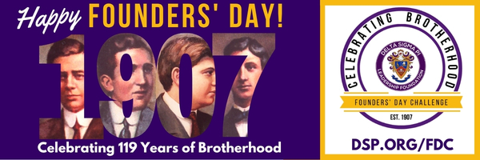
Subject Line: Support your chapter TODAY for Founders’ Day!
Dear [FIRST NAME],
Happy Founders’ Day! To celebrate Founders’ Day, consider donating to my chapter’s Chapter Leadership Fund during the Founders’ Day Challenge.
Why should you support our Chapter Leadership Fund? Chapter Leadership Funds help us reduce costs for Delta Sigma Pi educational programs, including registration, travel, and lodging. CLFs can also be used to cover expenses for educational or professional events like speakers, workshops, and conferences. By donating to our CLF, we can send more members to Fraternity events! If you want to learn more about the impact of CLFs, click here.
This is the perfect opportunity to give back to my chapter, [INSERT CHAPTER NAME]. To make a direct donation to my chapter’s CLF, click here: [INSERT YOUR CHAPTER’S CLF LINK]. To learn more about Founders’ Day challenge, go to dsp.org/fdc.
Thank you for supporting the future of [INSERT CHAPTER NAME]!
Fraternally,
[YOUR NAME]

EMAIL TO DONORS/SUPPORTERS (AFTER FDC IS OVER) – Send Nov 8-14
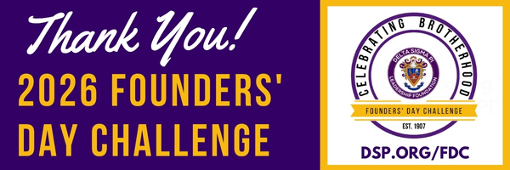
Subject line: Thank you for supporting Delta Sigma Pi!
Dear [FIRST NAME],
Thank you for supporting Delta Sigma Pi’s Founders’ Day Challenge. We raised more than $XXX,XXX [INSERT NUMBER SHOWCASED ON dsp.org/fdc]!
Because of your generosity, we will be able to use our Chapter Leadership Fund to send brothers to LEAD events, Grand Chapter Congress, host professional development speakers and more!
If you have specific questions regarding your gift, please email foundation@dsp.org or call (513) 523-1907.
The success of Founders’ Day 2026 would not have been possible without you! Thank you for your generosity.
Happy Founders’ Day!
[YOUR NAME]

