Across
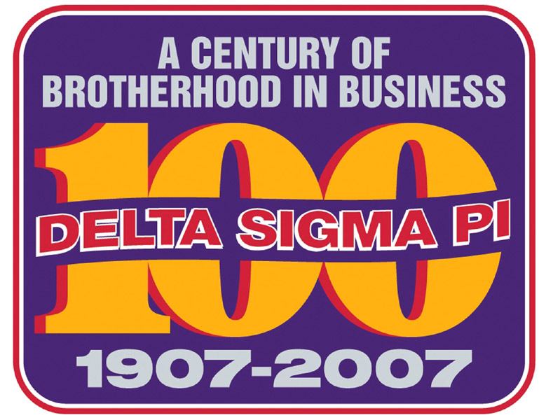
Delta Sigma Pi Centennial Crossword Puzzle
100 Questions Covering 100 Years of Brotherhood!
1. Southern-most Deltasig collegiate chapter
3. Mazur followed him
9. It will be celebrated in 2007
14. An oath or a Deltasig to be
17. Congresses are held in them
18. Founder’s wife or part of song title
19. First elected national president
21. Longest serving C.O. head
22. Arena named after this Deltasig of the Year
23. The C.O.’s first arrived in 1982
28. A chapter here made us international
29. Headquarters home and a shoe
31. "Windy City" home of the CO
32. A pledge’s delta has one
34. First woman elected GP
35. What we mix with pleasure
38. He wrote our favorite song
40. There are 24 of them
42. A new initiate badge is obtained through a ______
45. Six Deltasig collegiate chapters established in this city
48. Province divided in two
50. Gig’s digs were here
53. Blew us away - from New Orleans Centennial
54. Officers wear for initiation
55. Number 12 in a Greek series
56. Presented to the #1 graduating senior in commerce and business administration
58. An initiation must
60. This fraternity cornerstone was adopted in 1921
61. I’m going to attend Centennial Congress August 8-12, 2007 in _____
63. Archives room benefactor
66. The C.O. got two new ones in 1970
67. Married name of two former National COYs
69. Central Office’s closest collegiate chapter neighbor
72. Each chapter entitled to one at GCC
75. Coordinated move to Ohio and building of Central Office
76. 75th Anniversary celebrated here
78. Type of initiate on a campus
80. Commonly used abbreviation for our Fraternity
83. Type of initiate
85. This officer presides at chapter meetings
88. Grand President or hotel
89. Its Number 100
90. Founder’s initials or a chapeau
91. It’s an end and a beginning for a brother
93. Only founder to visit the Central Office in Oxford
94. Length of your fraternal brotherhood
95. Popular beverage dispenser disallowed per "risk management"
96. DSP encourages this

Down
2. One of our Fab Four
4. A "ritualistic" pledge
5. GCC held on this foreign island
6. Western-most Deltasig collegiate chapter
7. Title long before Educational and Leadership Consultant
8. Congress attendance king
10. Number on the DSP Board of Directors
11. It accredits degree programs in Bus. Ad., abbr.
12. Pink _____
13. The Board of Directors was formerly known as the Grand ____
15. We’re this kind of fraternity
16. First GCC was held in this city
20. Badge eyes
24. The alpha of fraternities
25. A Grand President or an O’Neal
26. 1977 Congress site
27. This tavern was the CO prototype
28. Oldest founder
30. Staffer or Red Sox hero
33. DSP was founded here, abbr.
36. It premiered in 1911
37. There are five of these
39. Color of an old Deltasig dog
41. Provides program support to scholarships, leadership development training and professional improvement
43. It’s under the crown
44. The Purpose is also called this
46. Chapter consultants once lived here
47. In 1975, membership for this group of individuals was authorized
49. Last Grand President to serve with Gig Wright as Executive Director
51. GP who worked at the CO
52. This club became DSP’s "Beta test"
54. Provinces have these
57. Ritual boss
59. Founder and first chapter president
62. Type of initiate
64. It may be a chapter professional program
65. GCC held on this American island
68. International chapter founded in this French-speaking city
70. Deltasig’s 24k group
71. The C.O. is on this avenue
73. This award may be silver or gold
74. DSP is one of _____ Greek-letter fraternities headquartered in Oxford
76. A performance measurement, abbr.
77. "When the shades of ___ are falling"
79. Undergraduate has-beens
81. One Founder’s favorite holiday?
82. This chapter moved from one university to another
84. These academies educate Deltasigs, abbr.
86. This chapter established in Oxford
87. A Deltasig color
88. Chapters get in big trouble for this
92. Minimum number of collegiate chapter officers

